Tutorial Membuat Task Scheduler Backup Otomatis Database oracle PBB

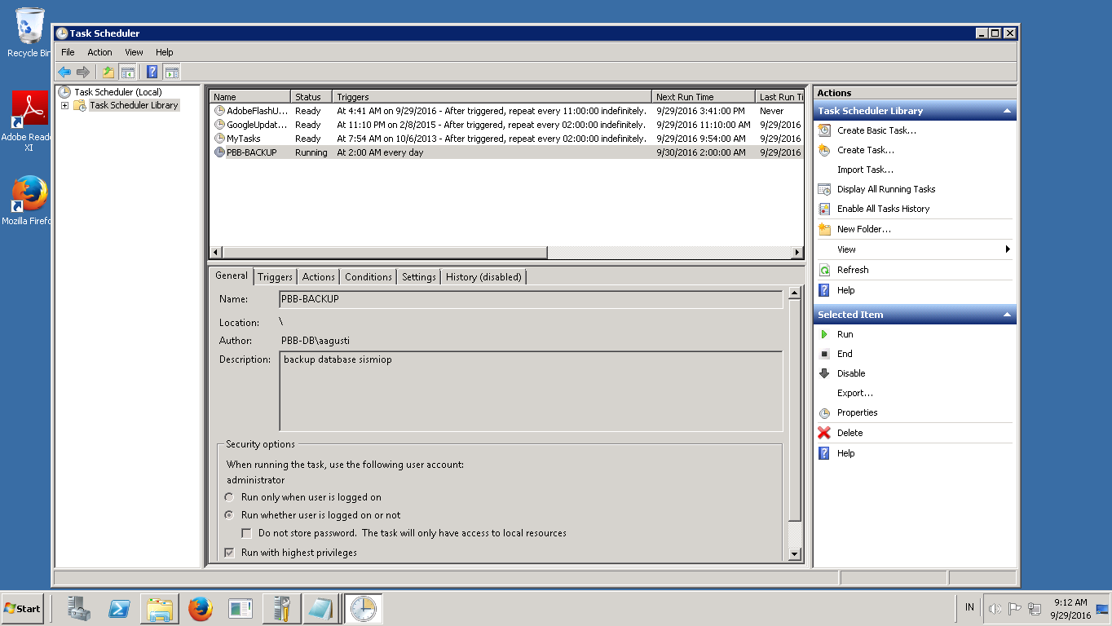

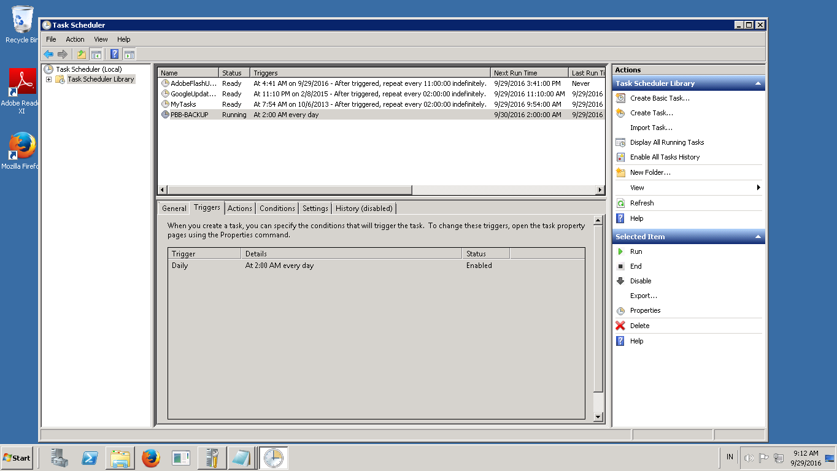

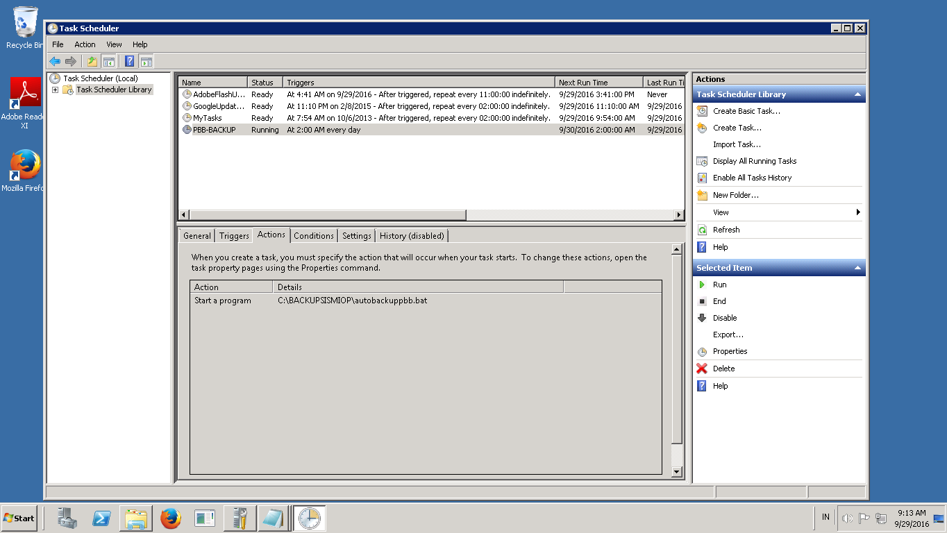

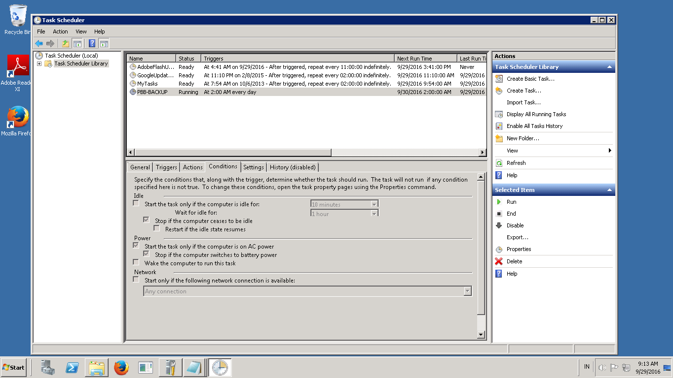

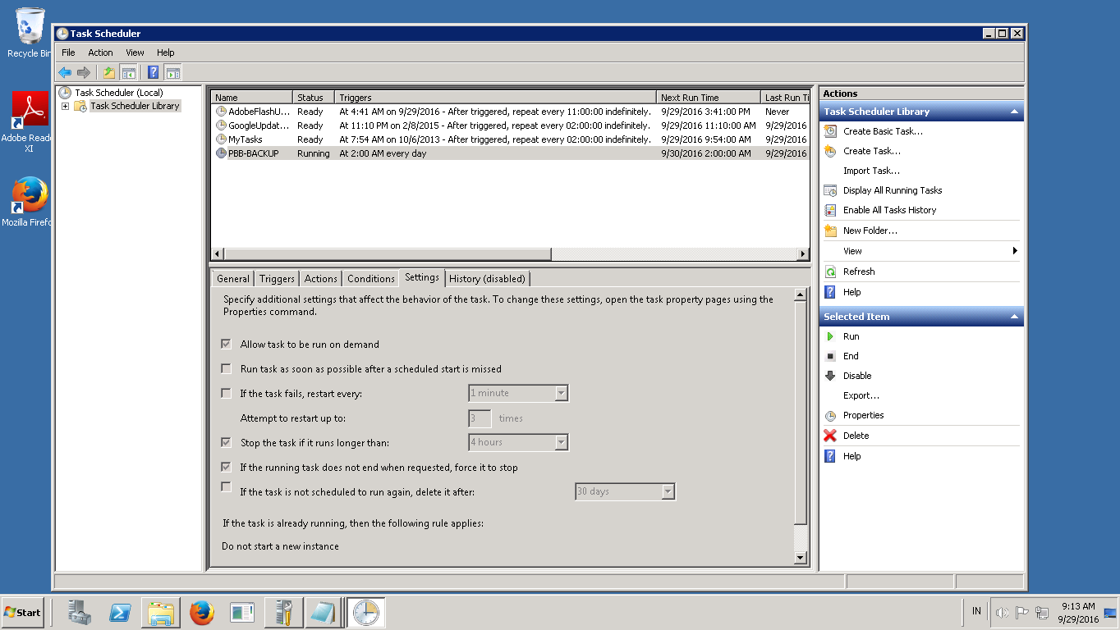

Script:

@echo off

REM for /f "tokens=1" %%i in ('date /t') do set DATE_DOW=%%i

REM for /f "tokens=2" %%i in ('date /t') do set DATE_DAY=%%i

REM for /f %%i in ('echo %date_day:/=-%') do set DATE_DAY=%%i

REM for /f %%i in ('time /t') do set DATE_TIME=%%i

REM for /f %%i in ('echo %date_time::=-%') do set DATE_TIME=%%i

REM jam, menit, detik

set hour=%time:~0,2%

if "%hour:~0,1%" == " " set hour=0%hour:~1,1%

set min=%time:~3,2%

if "%min:~0,1%" == " " set min=0%min:~1,1%

set secs=%time:~6,2%

if "%secs:~0,1%" == " " set secs=0%secs:~1,1%

REM tgl, bln, thn

set year=%date:~-4%

set month=%date:~3,2%

echo month

if "%month:~0,1%" == " " set month=0%month:~1,1%

set day=%date:~0,2%

if "%day:~0,1%" == " " set day=0%day:~1,1%

set datef=%year%%month%%day%

set timef=%hour%%min%%secs%

REM format => {tgl}{bln}{thn}_{jam}{mnt}{dtk}_namafile.sql

C:

cd \BACKUPSISMIOP

echo DATA_%datef%_%timef%.dmp

rem exp PBB/Z2184SDNHGF8121RT58 file=DATA_%datef%_%timef%.dmp